**CNN.ipynb:**

Before running the program, users must install tensorflow using the pip install command on the console window. This should also automatically install keras, h5py, Matplitlib, and numpy. In case the modules above were not installed, users should pip install them as well.

**Balloon Flight:**

For this game, user must make sure to have installed the modules pygame and random. Then students must create a text document that is named “high-scores.txt” like in the image below. The text document must be in the same location as the Balloon Flight python program. The folder “images” must contain the images that you would like to use.

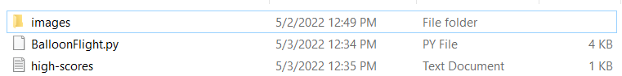

Inside the high-scores text file, input some 0s with space in between each one, like in the image below. Each one will represent one high score in the code. The more numbers that were used, the more high scores that will be available.

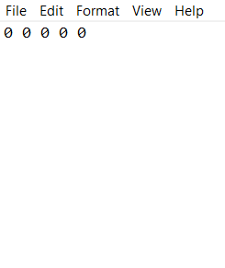

Another thing is to make sure you label the location of the high-score file correctly in the line of code below. This way, the python code will know where to find the high scores file.



If you require help to find the location of your high scores file, you can drag the high scores file into the console window of python to find the path. The steps to do so are shown below.

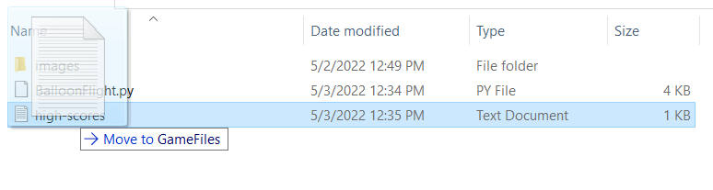

First pick up and drag your text file.

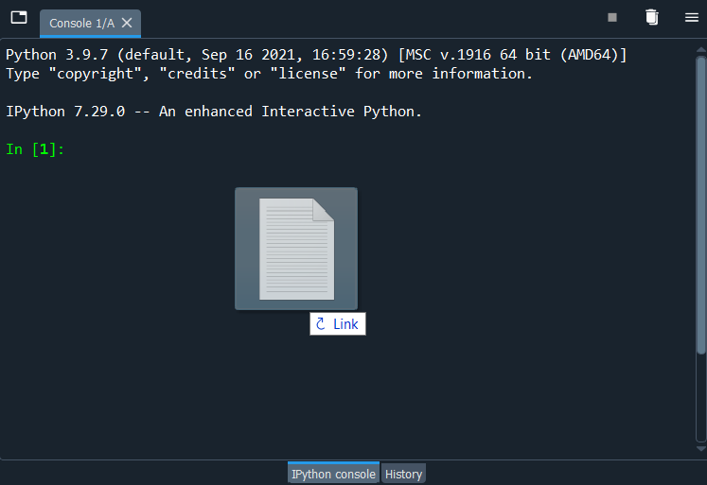

Drag the file into the console.

`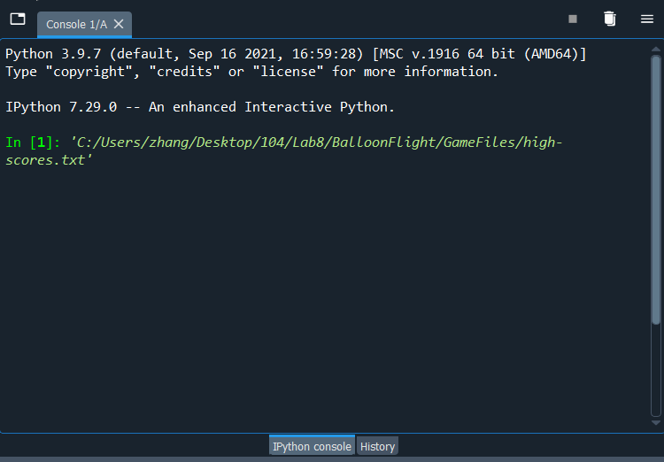

And the path will be displayed.